**Declaration of DA Allowance during Swacchta Pakhwara, Uttarakhand**

Date:24/11/17

Respected sir,

To implementation UJALA Program in Swachhta Pakhwara in Chamoli district Uttarakhand and also to give training to Department of the post in Chamoli and Pauri division post offices.

During my tour the details of DA allowance (Rs.600/day) :

|  |  |  |  |  |
| --- | --- | --- | --- | --- |
| Tour Period |  | NO. of days | DA allowance Per day | total Amount |
| starting date | End date |  |  |  |
| 04/10/2017 | 17/10/2017 | 14 | 600 | Rs.8400 |

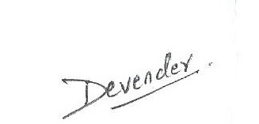

(DEVENDER SINGH CHAUHAN)

Sr.Engineer(EESL Dehradun)